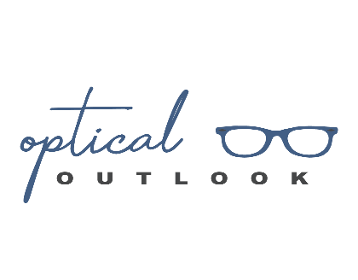
COVID-19 Pandemic Essential and Routine Eye Care and Treatment Consent Form

Please read the following statements and initial next to each statement to indicate your aggrement. If you cannot positively affirm to these questions, you will be asked to postpone or reschedule your appointment.

______ 1. I do not currently, nor have I had in the last 2 weeks, a fever, cough, sore throat, loss of
smell/taste or other COVID symptoms.
______ 2. To the best of my knowledge, I do not have, nor have been in direct contact with someone
who has a confirmed diagnosis of COVID-19 or a presumptive positive COVID-19 test result in the in the last 30 days.

I have read the above statements and answered the health questions honestly and to the best of my knowledge. I understand that Optical Outlook, its doctor and staff are taking precautions to limit any potential exposure I may have to the COVI-19 virus. I also understand that there is no definitive way to eliminate potential exposure completely.
By signing the form, I agree that I will not hold Optical Outlook, Dr Ahmann, or any of the staff personally responsible should I, or someone I come in contact with, become positive or presumptive positive with the COVID-19 virus. There are certain inherent risks accociated with any eye exam during a pandemic and I assume full responsibility for personal illness that may result and further release and discharge Optical Outlook, Dr Ahmann, and staff for injury, loss or damage arising out of my visit. I understand that COVID-19 infection can lead to illness, disability and even death and knowingly take the risk of exposure as I deam my eye exam to be essential to the maintenance of my vision.

Printed name____________________________

Signature ______________________________

Date _________________

